**Program 12:** Input a String, count and display the number of vowels, consonants, uppercase, lowercase

characters in string.

**Input:**

a=input('Enter the string: ')

v=0

c=0

up=0

lc=0

for i in a:

if i not in ‘ ’:

if i in 'AEIOUaeiou':

v+=1

else:

c+=1

if i.isupper():

up+=1

if i.islower():

lc+=1

print('Number of vowels are',v)

print('Number of consonants are',c)

print('Number of uppercase letters are',up)

print('Number of lowercase letters are',lc)

**Output:**

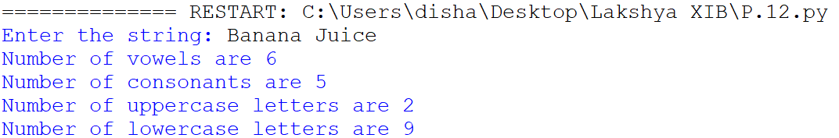

**Program 13:** WAP that should perform the following four tasks:

(i) After getting a word (of input) from the user, your program should use a while (or for) loop to

print out each of the letters of the word.

(ii) Your program should then use another loop to print out each of the letters of the (same) word in

reverse order.

(iii) Make a new variable that is the original word in reverse and print that variable.

(iv) Ask the user for a letter to count. Use another loop to count how many times that letter appears

in the original word. Print out this count.

**Input:**

a=input('Enter a string: ')

for i in a:

print(i)

for j in range(len(a)-1,-1,-1):

print(a[j])

for k in range(len(a)-1,-1,-1):

print(a[k],end='')

l=input('\nEnter the letter to count: ')

c=0

for m in a:

if l in m:

c+=1

print('The amount of times the letter',l,'has appeared are',c)

**Output:**

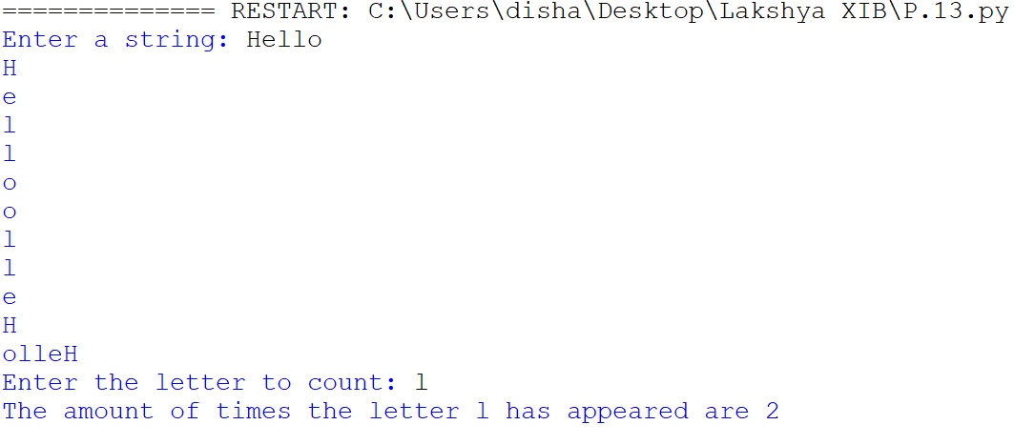

**Program 14:** Twisted Pig Latin. Prompt the user to enter a single word. Then form a new word by taking the

first letter of the original word, moving it to the end, and adding “ay”. Thus “school” becomes

“choolsay”.

**Input:**

a=input('Enter a string: ')

print(a[1:]+a[0]+'ay')

**Output:**



**Program 15:** Write a menu driven program to perform the following tasks:

(i) To check whether the string is a palindrome or not.

(ii) Reads a line, counts the words and then displays how many words are there in the line.

(iii) Reads a line, counts how many times a substring appears in the line and then displays the count.

(iv) Reads a line, counts and display the occurrence of words starting with a vowel in the given line.

**Input:**

a=input("Enter the string: ")

print('[1] Whether string is palindrome.\n[2] Count the words and display how many strings are there.\n[3] How many times a substring appears in the line and then displays the count.\n[4] Display the occurrence of words starting with a vowel in the given line.\n[5] Exit ')

while True:

opt=int(input('Which of the follwing tasks you want to run(choose accordingly from 1 to 5): '))

if opt==1:

pal=''

for i in range(len(a)-1,-1,-1):

pal+=a[i]

if a==pal:

print("the string is palindrome.")

else:

print("The string is not palindrome.")

if opt==2:

wc=a.split()

print('The number of the words in the given string are',len(wc))

if opt==3:

sub=input('Enter a substring: ')

co=0

wc=a.split()

for i in wc:

if i==sub:

co+=1

print('The substring',sub,'has appeared',co,'times.')

if opt==4:

v=0

wc=a.split()

for i in range(len(wc)):

if wc[i][0] in 'AEIOUaeiou':

v+=1

print('The amount of the words that start with vowel are',v)

if opt==5:

break

re=input('Do you want to try again[Yy/Nn]: ')

if re in 'Nn':

break

**Output:**

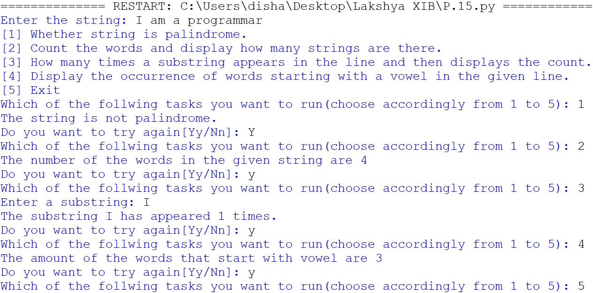

**Program 16:** Write a program that returns the largest and the smallest even number in the list of integers. If there is no even number in the input, print “No even element”.

**Input:**

n=eval(input('Enter the list: '))

b=[]

for i in n:

if i%2==0:

if i not in b:

b.append(i)

flag=len(b)

if flag>0:

print('The biggest even number is:',max(b))

print('The smallest even number is:',min(b))

if flag==0:

print('There is no even element in the given list')

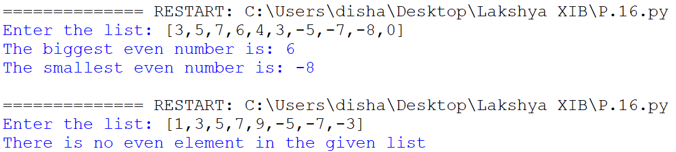**Output:**

**Program 17:** Write a menu driven program to perform the following tasks:

(i) To find the median from the given list of integers.

(ii) To find the mode from the given list of integers.

(iii) To find the range from the given list of integers.

**Input:**

re=0

a=[]

mode=[]

final_mode=[]

final_final_mode=[]

n=int(input('enter the size of list: '))

for i in range(n):

ele=int(input('enter the element: '))

a.append(ele)

while re!=4:

print('[1]The median of the given list.\n[2]The mode of the given list.\n[3]The range of the given list.\n[4]Exit.')

opt=int(input('Which of the following you want to find out about the list of integers(enter from 1 to 4 respectively): ' ))

if opt==1:

if n%2==0:

a.sort()

print('The median of the given list is',(a[int(n/2)-1]+a[int(n/2)])/2)

if n%2!=0:

a.sort()

print('The median of the given list is',a[int((n+1)/2)-1])

if opt==2:

mod=0

for j in a:

for k in range(n):

if j==a[k] and a.index(j)!=k:

mod+=1

if mod==0:

print('There is no mode of the given list as no element is repeated')

if mod!=0:

for l in a:

num=0

if l not in mode:

mode.append(l)

for m in range(n):

if l==a[m]:

num+=1

mode.append(num)

for q in range(1,len(mode),2):

final_mode.append(mode[q])

for r in range(0,len(mode),2):

final_final_mode.append(mode[r])

for x in range(len(final_mode)):

if max(final_mode)==final_mode[x]:

print('The mode of the given list is',final_final_mode[x])

if opt==3:

a.sort()

print('The range of the given list is',a[len(a)-1]-a[0])

if opt==4:

break

retry=input('Do you want to try again?(Yy/Nn): ')

if retry in 'Yy':

re+=1

else:

break

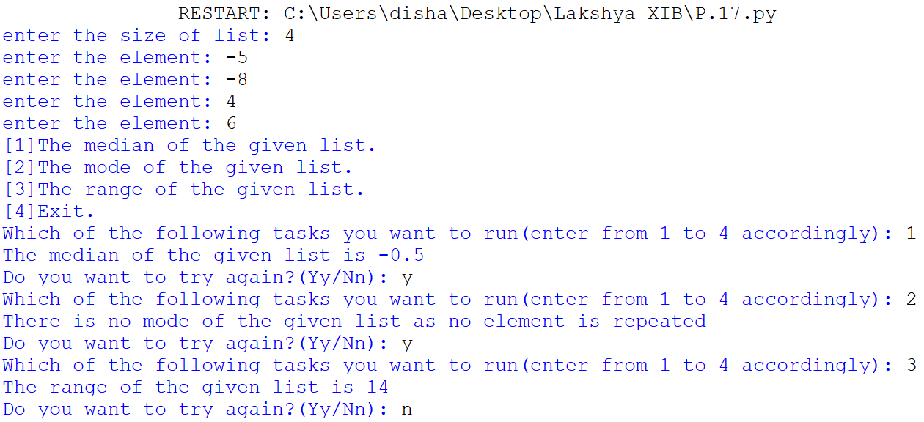**Output:**

**Program 19:** WAP to shift the negative integers to right and the positive integers to left.

**Input:**

a=eval(input('Enter the list: '))

print('Old list:',a)

b=[]

for i in a:

if i>=0:

b.append(i)

for j in a:

if j<0:

b.append(j)

print('New list:',b)

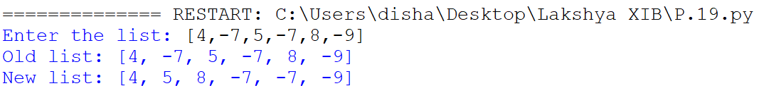**Output:**

**Program 20:** WAP to shift elements of a list so that the first element moves to the second index and the

second index moves to the third index, etc., and the last element shifts to the first position.

**Input:**

a=eval(input('Enter the list: '))

temp=a[len(a)-1]

print('actual list: ',a)

for i in range(len(a)-1,0,-1):

a[i]=a[i-1]

a[0]=temp

print('New list: ',a)

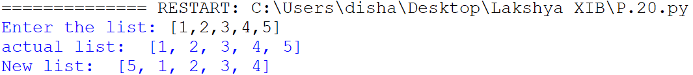**Output:**

**Program 21:** WAP to accept values from a user. Add a tuple to it and display its elements one by one. Also

display its maximum and minimum value.

**Input:**

tup=()

n=int(input('enter the number of values: '))

for i in range (n):

ele=int(input('enter the element: '))

tup+=(ele,)

print('This is the tuple:',tup)

print('the maximum value from the list of elements is',max(tup))

print('The minimum value from the list of elements is',min(tup))

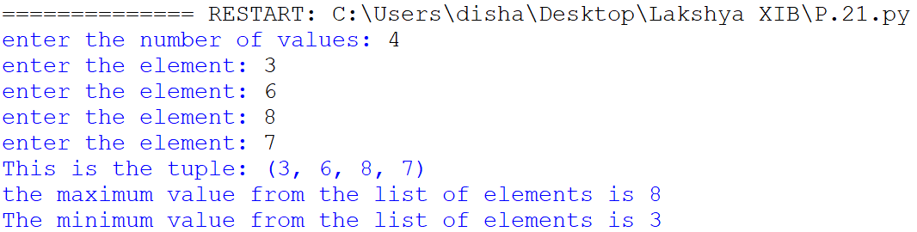**Output:**

**Program 22:** WAP that inputs a number n(integer) and creates a tuple containing: n, 2n, 3n and 4n.

**Input:**

n=int(input('Enter the number: '))

tup=(n,2*n,3*n,4*n)

print('this is the resulted tuple:',tup)

**Output:**



**Program 23:** WAP to input names of ‘n’ countries and their capital and currency, store it in a dictionary and display in tabular form. Also search and display for a particular country.

Input:

n=int(input('enter the amount of countries: '))

list={}

print('.'*50)

for i in range(n):

coun=input('Name of the country: ')

cap=input('Enter the capital: ')

cur=input('name of the currency: ')

list[coun]=[cap,cur]

print('.'*50)

while True:

sear=input('enter the country to search for: ')

print('The capital and currency of the country',sear,'is',list[sear][0],'and',list[sear][1])

re=input('Do you want to search again(Yy/Nn): ')

if re in 'Nn':

break

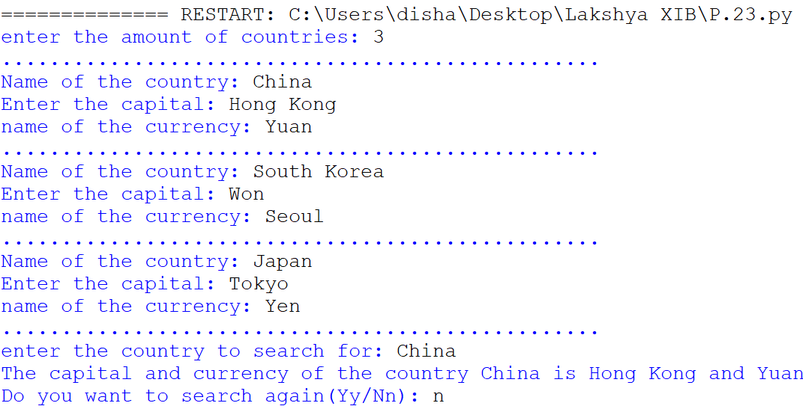**Output:**

**Program 24:** WAP to store student names and their percentage in a dictionary, delete a particular student

name from the dictionary. Also display dictionary after deletion.

**Input:**

list={}

tot=int(input('Enter the amount of students: '))

print('.'*50)

for i in range (tot):

stu=input('Enter the name of the student: ')

per=input('Enter the percentage of said student: ')

list[stu]=per

print('.'*50)

while True:

de=input('Who is the student you want to remove from the said list: ')

del list[de]

re=input('Do you want to remove more students?(Yy/Nn): ')

if re in 'Nn':

break

print('These are the students in the dictionary after deletion:')

print('Student\t | \tPercentage')

for j in list:

print(j,'\t | \t',list[j])

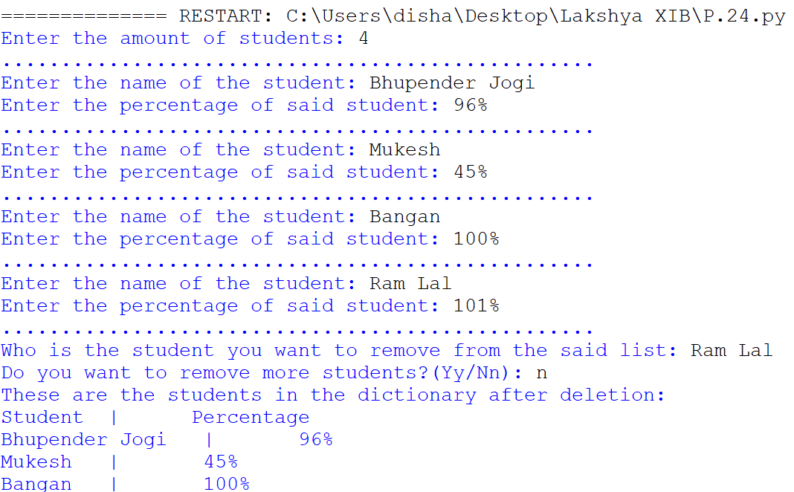**Output:**

**Program 25:** Write a program in Python that calculates the following:

· Area of a circle

· Circumference of a circle

· Area of a rectangle

· Perimeter of a rectangle

Create respective modules for each of the operations and call them separately using a menu-driven

program.

**Input for Rectangle:**

def area_rectangle(length,breadth):

return length*breadth

def perimeter_rectangle(length,breadth):

return 2*(length+breadth)

**Input for circle:**

import math

def area_circle(radius):

return math.pi*(radius**2)

def circumference_circle(radius):

return 2*math.pi*(radius)

**Main Input:**

import circle

import rectangle

print('Which of the following you want to calculate?(choose according from 1 to 5):\n[1] Area of a circle.\n[2] Circumference of the circle.\n[3] Area of a rectangle.\n[4] Perimeter of a rectangle.\n[5] Exit.')

while True:

ch=int(input('Please enter your choice: '))

if ch==1:

radius=int(input('Enter the radius: '))

print("The area of the circle:",circle.area_circle(radius))

if ch==2:

radius=int(input('Enter the radius: '))

print("The circumference of the circle:",circle.circumference_circle(radius))

if ch==3:

length=int(input('Enter the length: '))

breadth=int(input('Enter the breadth: '))

print('The area of the rectangle:',rectangle.area_rectangle(length,breadth))

if ch==4:

length=int(input('Enter the length: '))

breadth=int(input('Enter the breadth: '))

print('The perimeter of the rectangle:',rectangle.perimeter_rectangle(length,breadth))

if ch==5:

break

re=input('Do you want to try again?(Yy/Nn): ')

if re in 'Nn':

break

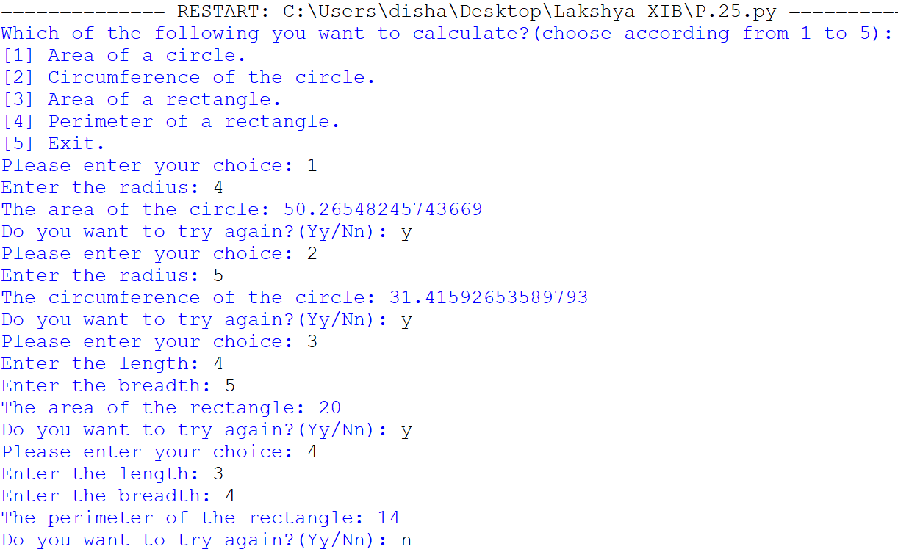**Output:**